LECTURE 3
CONCEPT DATA MODELING

Data Model
A data model is a structured representation of how data is organized, stored, and managed in a database system. It defines the entities (objects), their attributes (properties), the relationships between them, and the constraints or rules that apply to the data. A data model serves as a blueprint for designing databases and helps ensure that the database structure supports business requirements efficiently. It also acts as a communication tool between business users and technical developers.
Example: In a university system, entities such as Student, Course, and Instructor are identified. Attributes like Student_ID, Name, and Email describe the Student entity. A relationship such as “Student enrolls in Course” connects the entities.

Types of Data Model (Abstraction Based)
Data models are classified based on their level of abstraction, meaning how much detail they provide about the system. There are three main types: Conceptual, Logical, and Physical data models. Each level builds upon the previous one, moving from a broad overview of the system to detailed technical implementation. This layered approach ensures clarity, accuracy, and smooth database development.
Example: In an online shopping system, we first identify main business objects like Customer and Order (Conceptual), then define their attributes and keys (Logical), and finally create actual database tables with data types in MySQL (Physical).
Conceptual Data Model
The conceptual data model is the highest level of abstraction and focuses on the overall structure of the system. It identifies the main entities, their relationships, and basic business rules without including technical details such as data types or primary keys. This model is easy to understand and is mainly used during requirement gathering and system analysis. It ensures that stakeholders agree on what data needs to be stored.
Example: In a hospital system, the conceptual model may include entities such as Patient, Doctor, and Appointment. It may show relationships like “Patient books Appointment” and “Doctor attends Appointment,” without specifying attributes like data types.
Logical Data Model
The logical data model provides more detail than the conceptual model and describes the structure of data in a more organized way. It defines entities, attributes, primary keys, foreign keys, and relationships clearly. However, it remains independent of any specific database management system (DBMS). This model ensures that data is structured properly before implementation.
Example: In the logical model of a school system:
- Student entity includes attributes: Student_ID (Primary Key), Name, Date_of_Birth.
- Course entity includes Course_ID (Primary Key), Course_Name.
- A relationship is created using Course_ID as a Foreign Key in the Student table.
Physical Data Model
The physical data model is the lowest level of abstraction and focuses on how data is actually stored in a specific database system. It includes detailed technical information such as table names, column names, data types, indexes, constraints, and storage settings. This model depends on the chosen DBMS (e.g., MySQL, Oracle) and is used by database developers to create the actual database.
Example: In MySQL, the Student table may be created as:
- Student_ID INT PRIMARY KEY
- Name VARCHAR(50)
- Date_of_Birth DATE
- Course_ID INT (Foreign Key)
This model ensures that the database is properly implemented and optimized for performance.

Data Model Types in DBMS
In a Database Management System (DBMS), different data models are used to define how data is structured, stored, and accessed. Each model organizes data in a different way and is suitable for different types of applications. The main data models in DBMS include the Relational, Hierarchical, Network, Entity-Relationship (ER), Object-Oriented, and NoSQL models.
Relational Model
The Relational Model is the most widely used data model in modern database systems. It organizes data into tables called relations. Each table consists of rows (tuples) and columns (attributes). Relationships between tables are created using primary keys and foreign keys. This model uses Structured Query Language (SQL) to store and retrieve data efficiently. It is simple, flexible, and suitable for most business applications.
Example: In a college database, a Student table may contain Student_ID, Name, and Course_ID. A Course table may contain Course_ID and Course_Name. The Course_ID acts as a foreign key in the Student table to create a relationship between the two tables.
Hierarchical Model
The Hierarchical Model organizes data in a tree-like structure. It has a single root node, and each child record has only one parent record. This model represents one-to-many relationships naturally. However, it does not easily support many-to-many relationships. It was widely used in early database systems.
Example: In a company database, a Department may be the parent, and Employees may be children under that department. Each employee belongs to only one department.
Network Model
The Network Model is an extension of the hierarchical model. It allows a child record to have multiple parent records, making it more flexible. It supports many-to-many relationships and organizes data in a graph-like structure. Although more powerful than the hierarchical model, it is also more complex to design and maintain.
Example: In a university system, a Student can enroll in multiple Courses, and a Course can have multiple Students. This many-to-many relationship is easily represented in the network model.
Entity-Relationship (ER) Model
The Entity-Relationship (ER) Model is a high-level conceptual model used mainly for database design. It represents data using entities, attributes, and relationships. ER diagrams visually show how different entities are connected. This model is mainly used during the planning and design stage before implementing the database.
Example: In a hospital system, entities such as Patient, Doctor, and Appointment are connected through relationships like “Patient books Appointment.”
Object-Oriented Model
The Object-Oriented Model stores data in the form of objects, similar to object-oriented programming languages. Each object contains both data (attributes) and behavior (methods). This model is suitable for applications that require complex data representations such as multimedia systems or real-time applications.
Example: A Student object may contain attributes like Name and Age, and methods like calculateGrade().
NoSQL Models
NoSQL models are designed to handle large volumes of unstructured or semi-structured data. They provide flexibility, scalability, and high performance, especially for big data and web applications. NoSQL databases do not strictly follow the table-based relational structure. They include types such as document-based, key-value, column-based, and graph databases.
Example: In a social media application, user posts, comments, and likes can be stored in a document-based NoSQL database like MongoDB, where each user’s data is stored as a flexible JSON document.

Importance of Conceptual Data Model
1. Clear Understanding of Business Requirements
The conceptual data model helps in identifying the main entities, relationships, and business rules of a system. It ensures that all important data elements are captured according to real-world requirements before technical design begins.
2. Communication Tool
Since it does not include technical details, the conceptual model is easy for non-technical stakeholders to understand. It acts as a bridge between business users and technical developers.
3. Early Error Detection
At the conceptual stage, missing entities, incorrect relationships, and inconsistencies can be identified. Detecting these issues early reduces development time and cost.
4. Foundation for Logical and Physical Models
The conceptual data model serves as the base for creating logical and physical data models. A well-designed conceptual model leads to a well-structured database.
Example
In an e-commerce system, identifying entities such as Customer, Product, and Order ensures that all core business data is properly defined before implementation.

Goal of Conceptual Data Modeling
The goal of conceptual data modeling is to clearly understand and represent an organization’s data requirements at a high level. It identifies the main entities, their attributes, relationships, and business rules using an ER diagram.
It ensures that real-world objects and their interactions are properly captured before moving to technical database design. It also improves communication between business users and developers and provides a solid foundation for logical and physical database design.

Result of Conceptual Data Modeling
The result of conceptual data modeling is a complete and validated ER diagram that accurately reflects the organization’s data structure. It clearly defines entities, keys, relationships, cardinality, and participation constraints.
This ER diagram acts as a blueprint for database development, reduces errors and redundancy, and ensures that the final database system aligns with business requirements.

Advantages of ER Diagrams
1. Visual Representation
ER diagrams provide a graphical representation of entities, attributes, and relationships. This makes complex database structures easier to understand.
2. Improved Communication
They help analysts, designers, and stakeholders clearly understand how data is organized and connected.
3. Clear Identification of Relationships
ER diagrams clearly show relationship types such as one-to-one, one-to-many, and many-to-many. They also help identify primary keys and foreign keys.
4. Support for Database Design
ER diagrams act as a blueprint for converting conceptual design into logical and physical database structures.
5. Reduction of Redundancy
By clearly defining entities and relationships, ER diagrams help reduce data duplication and support normalization.
Example
An ER diagram showing Student, Course, and Enrollment makes it easier to design how students register for courses in a database.

Introduction to Entity-Relationship (E-R) Modeling
1. Definition
Entity-Relationship (E-R) modeling is a conceptual method used to design and represent the structure of a database system. It models real-world objects and their interactions.
2. Purpose
The main purpose of E-R modeling is to capture the meaning of data and relationships accurately before database implementation. It ensures better design and easier maintenance.
3. Main Components
E-R modeling is based on three main components:
- Entities – Real-world objects such as Student or Doctor
- Attributes – Properties of entities such as Name or Age
- Relationships – Connections between entities such as Student enrolls in Course
4. E-R Diagram
An E-R diagram is the graphical representation of entities, attributes, and relationships. It helps transform real-world requirements into a structured database design.
Example
In a hospital system, E-R modeling shows how Patient, Doctor, and Appointment are related before creating the actual database tables.

Entity–Relationship (E–R) Modeling – Key Terms
Entity–Relationship modeling is a conceptual technique used to represent data and its relationships in a structured and visual manner. The following key terms form the foundation of ER modeling.
1. Entity
An entity is any real-world object, person, place, event, or concept about which an organization wants to store information. Entities represent the major data objects in a system and are the primary building blocks of an ER model. In an ER diagram, an entity is represented by a rectangle.
Each entity has instances. For example, if Student is an entity, then each individual student (such as John or Sara) is an instance of that entity.
Example: Student, Employee, Product, Department.
2. Entity Type
An entity type is a collection of entities that share the same set of attributes or characteristics. It defines the structure that all instances of that entity must follow.
For example, the entity type Student may have attributes such as Student_ID, Name, and Date_of_Birth. Every student in the system will follow this same structure.
Thus, the entity type defines the template, while entity instances are the actual data records.
3. Attribute
An attribute is a property or characteristic that describes an entity. Attributes provide specific details about an entity and help differentiate one entity instance from another. In ER diagrams, attributes are usually represented by ellipses connected to their respective entity.
For example, the entity Employee may have attributes such as Employee_ID, Name, Salary, and Hire_Date.
Attributes are important because they define what information will be stored about each entity.
Associative Entity
An associative entity is an entity that is created to resolve a many-to-many (M:N) relationship between two entities. It acts as a bridge between those entities and usually contains attributes that are specific to the relationship itself.
In relational databases, many-to-many relationships cannot be implemented directly. Therefore, an associative entity is introduced to break the M:N relationship into two one-to-many (1:N) relationships.
Purpose of an Associative Entity
- To resolve many-to-many relationships.
- To store additional attributes related to the relationship.
- To maintain data integrity and proper normalization.
Characteristics
- It has foreign keys from both participating entities.
- These foreign keys often form a composite primary key.
- It may include its own attributes that describe the relationship.
Example
Consider the relationship:
Student enrolls in Course
This is a many-to-many relationship because:
- A student can enroll in many courses.
- A course can have many students.
To implement this, an associative entity called Enrollment is created.
Enrollment may include:
- Student_ID (Foreign Key)
- Course_ID (Foreign Key)
- Enrollment_Date
- Grade
Here, Enrollment becomes a separate entity that connects Student and Course and stores additional information such as Grade.
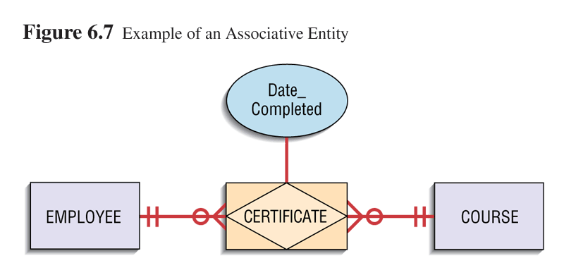
Types of Attributes
Attributes can be classified into different types based on their structure and behavior.
1. Simple Attribute
A simple attribute cannot be divided into smaller meaningful components. It represents a single, indivisible value.
Example: Age, Gender, Salary.
2. Composite Attribute
A composite attribute can be divided into smaller sub-attributes that have independent meaning.
Example: Address can be divided into Street, City, State, and Zip_Code.
Similarly, Full_Name can be divided into First_Name and Last_Name.
3. Derived Attribute
A derived attribute is one whose value can be calculated from other attributes. It is usually not stored permanently in the database but computed when needed.
Example: Age can be derived from Date_of_Birth.
Total_Amount can be derived from Quantity × Price.
4. Multivalued Attribute
A multivalued attribute is one that can have multiple values for a single entity instance. In ER diagrams, it is represented by a double-lined ellipse.
Example: A student may have multiple Phone_Numbers or Email_Addresses.
Keys and Identifiers
In order to uniquely distinguish each entity instance, keys are used.
1. Candidate Key
A candidate key is an attribute or a combination of attributes that uniquely identifies each instance of an entity type. An entity may have multiple candidate keys, but only one of them is selected as the primary identifier.
Example: In the Student entity, both Student_ID and National_ID may uniquely identify a student. Therefore, both are candidate keys.
2. Identifier
An identifier is a candidate key that has been chosen to uniquely identify each instance of an entity type. It ensures that no two entity instances have the same value.
Primary Key
The primary key is the selected identifier used for unique identification in a database. It must be unique and cannot be null.
Example: Student_ID is often chosen as the primary key.
Foreign Key
A foreign key is an attribute in one entity that refers to the primary key of another entity. It is used to create and enforce relationships between entities.
Example: Course_ID in the Enrollment entity may reference the Course entity’s primary key.
Selection Rules for an Identifier
When selecting an identifier, certain guidelines should be followed:
- The chosen key should have a stable value that does not change over time.
- The key should never contain null values.
- Intelligent keys (keys containing meaningful data) should be avoided because their values may change.
- For large composite keys, it is often better to use a surrogate key (such as an auto-generated number).

Relationship
A relationship is an association between instances of one or more entity types. It shows how entities are logically connected in a system. Relationships are meaningful to the organization and usually represent real-world interactions. In ER diagrams, relationships are represented by diamonds and are labeled using verb phrases.
Example:
Student enrolls in Course
Doctor treats Patient
Employee works in Department
Relationships help integrate separate entities into a complete and meaningful database structure.
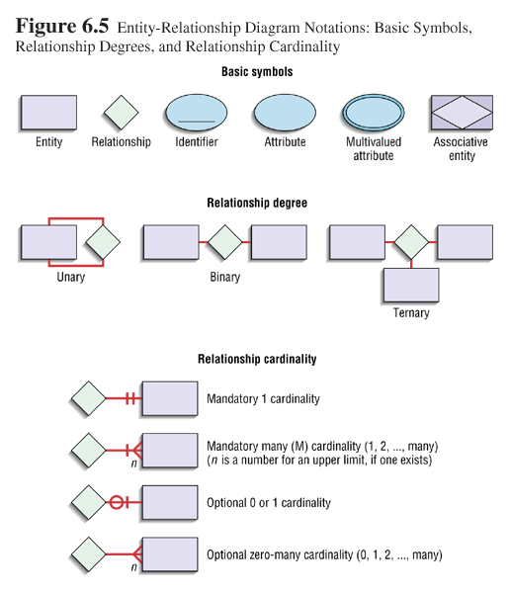
Degree of Relationship
The degree of a relationship in ER modeling refers to the number of entity types that participate in a particular relationship. It indicates how many different entities are involved in an association. Understanding the degree of a relationship is important because it determines how data is connected and how the relationship should be implemented in the database design.
Relationships are commonly classified into unary, binary, and ternary based on their degree.
Unary Relationship
A unary relationship involves only one entity type participating in the relationship. It is also known as a recursive relationship because the entity is related to itself. In this case, different instances of the same entity are connected.
Unary relationships are used when an entity has a relationship with other instances of the same entity type.
Example:
In an Employee entity, one employee may supervise another employee.
Employee supervises Employee.
Here, both supervisor and subordinate belong to the same entity type.
Binary Relationship
A binary relationship involves two different entity types. It is the most common type of relationship used in ER modeling. In this relationship, instances of one entity are associated with instances of another entity.
Binary relationships are simple to represent and are widely used in database design.
Example:
Student enrolls in Course.
Customer places Order.
Here, two distinct entities participate in the relationship.
Ternary Relationship
A ternary relationship involves three different entity types participating in a single relationship. It represents a situation where three entities are interconnected simultaneously.
A ternary relationship should not be replaced by three separate binary relationships unless the meaning remains the same. Sometimes, separating it may change the intended business logic.
Example:
Supplier supplies Product to Store.
In this case, Supplier, Product, and Store are all connected in one relationship.
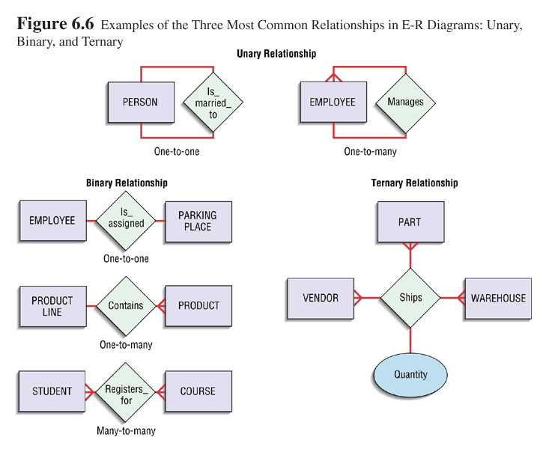
Types of Relationships
Relationships are also classified based on how many instances of one entity can be associated with instances of another entity. This classification is based on mapping cardinalities.
One-to-One (1:1) Relationship
In a one-to-one relationship, one instance of Entity A is associated with only one instance of Entity B, and vice versa.
This type of relationship is less common but is used when two entities are closely related.
Example:
One Person has one Passport.
Each passport belongs to exactly one person.
In database design, such relationships may sometimes be merged into a single table.
One-to-Many (1:N) Relationship
In a one-to-many relationship, one instance of an entity can be associated with multiple instances of another entity. However, each instance on the many side is associated with only one instance on the one side.
This is one of the most common relationship types in database systems.
Example:
One Department employs many Employees.
Each employee works in only one department.
In relational databases, this is usually implemented using a foreign key on the many side.
Many-to-Many (M:N) Relationship
In a many-to-many relationship, multiple instances of one entity can be associated with multiple instances of another entity.
This type of relationship cannot be directly implemented in relational databases and is typically resolved by creating an associative entity.
Example:
Students enroll in Courses.
A student can enroll in multiple courses, and a course can have multiple students.
To implement this, an Enrollment entity is created to link Students and Courses.
Recursive Relationship
A recursive relationship is a special type of unary relationship where an entity has a relationship with itself.
Example:
An Employee manages another Employee.
A Course may have a prerequisite Course.
Recursive relationships are useful when hierarchical structures exist within the same entity type.

Cardinality
Cardinality specifies the number of instances of one entity that can or must be associated with each instance of another entity in a relationship. It defines the numerical constraints of a relationship and helps ensure data integrity.
Cardinality is expressed using minimum and maximum values.
Minimum Cardinality
Minimum cardinality indicates the minimum number of relationship instances in which an entity must participate. It determines whether participation is mandatory or optional.
The minimum value is usually:
- 0 (optional participation)
- 1 (mandatory participation)
Example:
A student may enroll in zero or more courses.
Here, the minimum cardinality is zero.
Maximum Cardinality
Maximum cardinality indicates the maximum number of relationship instances in which an entity can participate.
The maximum value is usually:
- 1
- Many (N)
Example:
A department can have many employees.
The maximum cardinality from Department to Employee is many.
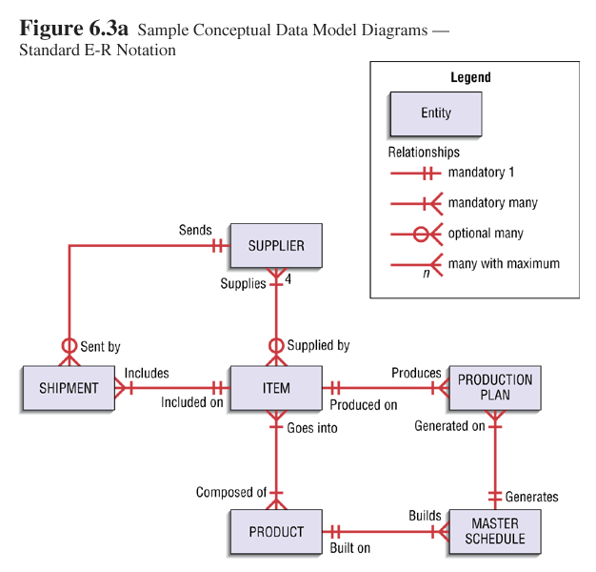
Participation
Participation refers to whether all or only some instances of an entity must participate in a relationship. It describes dependency between entities.
Total (Mandatory) Participation
In total participation, every instance of an entity must participate in at least one relationship instance. The entity cannot exist without being related.
Example:
Every Order must be placed by a Customer.
An order cannot exist without a customer.
In ER diagrams, total participation is often represented by a double line between the entity and the relationship.
Partial (Optional) Participation
In partial participation, some instances of an entity may not participate in the relationship. Participation is optional.
Example:
An employee may or may not be assigned to a project.
Some employees may not be involved in any project.
Partial participation is usually represented by a single line in ER diagrams.

Example ER Diagram (Detailed Structured Example)
Let us consider a University Management System as an example.
Entities and Attributes
- Student
  - Student_ID (Primary Key)
  - Name
  - Date_of_Birth
  - Email
- Course
  - Course_ID (Primary Key)
  - Course_Name
  - Credits
- Instructor
  - Instructor_ID (Primary Key)
  - Name
  - Department
- Enrollment (Associative Entity)
  - Student_ID (Foreign Key)
  - Course_ID (Foreign Key)
  - Enrollment_Date
  - Grade
Relationships
- Student enrolls in Course
  - Many-to-Many relationship
  - Resolved using Enrollment entity
- Instructor teaches Course
  - One-to-Many relationship
  - One instructor can teach many courses
  - Each course is taught by one instructor
Cardinality
- Student to Enrollment: One-to-Many
- Course to Enrollment: One-to-Many
- Instructor to Course: One-to-Many
Participation
- Enrollment has total participation with Student and Course (it cannot exist without both).
- A student may have partial participation if not enrolled in any course.
This structured example clearly shows entities, attributes, relationships, cardinality, participation, and associative entity usage.

Conceptual Data Modeling and the E-R Diagram
Conceptual data modeling focuses on capturing the meaning of data at a high level before technical implementation. The E-R diagram is the primary tool used in conceptual modeling to visually represent entities, attributes, and relationships.
It helps transform real-world business requirements into a structured model that can later be converted into logical and physical database designs.
The conceptual model does not include technical details like data types or storage methods. Its main purpose is to understand what data is needed and how it is related.

Electronic Commerce Development: Conceptual Data Model
Conceptual data modeling for electronic commerce (e-commerce) applications follows the same principles as traditional database design. The goal is to identify the key business entities, their attributes, and the relationships among them before implementing the system.
In e-commerce systems, the conceptual data model focuses on representing customers, products, orders, and purchasing activities clearly. Since online systems handle large volumes of transactions and user interactions, it is essential to design a well-structured conceptual model to ensure accuracy, scalability, and efficiency.
A well-developed conceptual data model helps:
- Understand how customers interact with the system.
- Define how products are managed and sold.
- Represent ordering and payment processes.
- Provide a strong foundation for logical and physical database design.
Pine Valley Furniture WebStore (Conceptual Example)
The Pine Valley Furniture WebStore is an example of an online retail system. Its conceptual data model identifies the major entities involved in online shopping and their relationships.
The four main entity types in this model are:
- Customer
- Inventory
- Order
- Shopping Cart
Each entity plays a specific role in the e-commerce process.
- Customer
The Customer entity represents individuals who browse products, add items to the cart, and place orders.
Possible Attributes
- Customer_ID (Primary Key)
- Name
- Email
- Phone_Number
- Address
Relationships
- A customer can create zero or many orders.
- A customer can have one active shopping cart at a time.
Cardinality
- Customer to Order: (0, N)
A customer may place no orders or many orders.
- Order to Customer: (1, 1)
Each order must belong to exactly one customer.
- Inventory
The Inventory entity represents the products available for sale in the web store. It stores product details and stock information.
Possible Attributes
- Product_ID (Primary Key)
- Product_Name
- Description
- Price
- Quantity_In_Stock
Relationships
- Inventory items are added to shopping carts.
- Inventory items appear in orders.
Cardinality
- Inventory to Order: (0, N)
A product may appear in many orders or none.
- Order to Inventory: (1, N)
Each order must contain at least one product.
This many-to-many relationship between Order and Inventory is typically resolved using an associative entity such as Order_Item.
- Order
The Order entity represents a confirmed purchase made by a customer.
Possible Attributes
- Order_ID (Primary Key)
- Order_Date
- Total_Amount
- Order_Status
Relationships
- Each order is placed by one customer.
- Each order contains one or more inventory items.
Participation
- Order has total participation with Customer (an order cannot exist without a customer).
- Order has total participation with Inventory through Order_Item (an order must include products).
- Shopping Cart
The Shopping Cart entity represents items selected by a customer before placing an order. It acts as a temporary holding area for products.
Possible Attributes
- Cart_ID (Primary Key)
- Creation_Date
- Status
Relationships
- A customer can have zero or one active shopping cart.
- A shopping cart can contain multiple inventory items.
Cardinality
- Customer to Shopping Cart: (0, 1)
A customer may or may not have an active cart.
- Shopping Cart to Inventory: (0, N)
A cart may contain multiple products.
The relationship between Shopping Cart and Inventory is also many-to-many and is resolved using an associative entity such as Cart_Item.
Overall Conceptual Flow in the WebStore
- A Customer browses Inventory.
- The Customer adds items to a Shopping Cart.
- The Customer places an Order based on the cart.
- The Order contains one or more Inventory items.
This conceptual model ensures that:
- Business rules are clearly defined.
- Relationships between entities are structured.
- The system can later be converted into logical and physical database models efficiently.

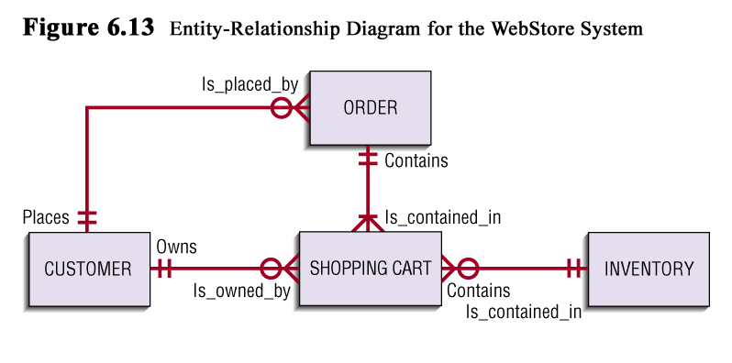
Relationship Analysis of above diagram
1. CUSTOMER — ORDER
Relationship: Places / Is_placed_by
- One customer can place many orders.
- Each order is placed by exactly one customer.
This is a 1:N relationship, which is correct for an e-commerce system.
Business logic is valid:
An order cannot exist without a customer.
2. CUSTOMER — SHOPPING CART
Relationship: Owns / Is_owned_by
- A customer may own zero or one shopping cart.
- Each shopping cart belongs to exactly one customer.
This is also correct.
It reflects the rule that a customer may not currently have an active cart.
3. SHOPPING CART — INVENTORY
Relationship: Contains / Is_contained_in
- A shopping cart can contain many inventory items.
- An inventory item can appear in many shopping carts.
This is a many-to-many (M:N) relationship, which is correct logically.
However, in an actual relational implementation, this would require an associative entity such as:
Cart_Item
- Cart_ID
- Product_ID
- Quantity
Conceptually, the diagram is fine.
4. ORDER — SHOPPING CART
Relationship: Contains / Is_contained_in
This appears to indicate:
- An order is created from a shopping cart.
- A shopping cart may or may not become an order.
This relationship is acceptable conceptually if the business rule is:
An order is generated from one shopping cart.
If the intention is that an order directly contains inventory items, then normally the relationship should be:
ORDER — INVENTORY (via Order_Item associative entity)
So academically, this part depends on the business rule being modeled.

